SHIREHAMPTON PUBLIC HALL NEWSLETTER
FEBRUARY 2023

The Public Hall was saddened to hear the news of the death of one of our stalwarts and ex-Trustees, Norman Sims, aged 94. Norman was a dedicated Trustee for many years, an amazing volunteer and the backbone of the Evergreens social group and the Bingo, both held regularly pre-pandemic on a Friday afternoon and evening at the Public Hall. Our heartfelt condolences are extended to Norman’s family and friends. Norman was a true gentleman and his smile and sense of humour will be sorely missed.
On another matter the Public Hall’s caretaker, Neil Robson, has sadly retired from our employ after 10 years of loyal service. We are sad to see you go, Neil, however we are eternally grateful for all you have done and wish you a very happy and healthy retirement.
At the User Group meeting on Friday 27th May 2022 a suggestion was made that a small article be written about regular groups that meet at the Hall. It was hoped that by introducing Shire Paper readers to what we have to offer they would feel part of the Hall community, and maybe even take part in a few activities (if they don’t already!).
This month we are showcasing the Model Railway Exhibition being held on Saturday 4th February:

Model Railway Show returns to the Public Hall!
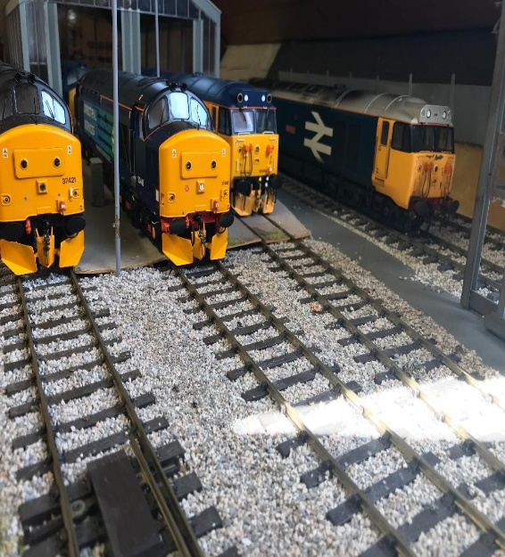

Shirehampton model railway club has held an annual exhibition of trains and working layouts in the public hall since 1992, but understandably the pandemic put paid to this over the last few years.

This fixture has always been very well supported by the people of Shirehampton and the neighbouring areas, and the great news is that this popular event returns in 2023 on Saturday 4th February from 10:00 until 17:00.

Entry is just £3.00 for adults or £5 for a family of four. There will be six layouts, some featuring in the model railway press or exhibited at the Warley national show, and also modelling demonstrations, specialist traders, refreshments, and raffle prizes.

We’re grateful for the ongoing support of our friends at Model Railways Direct from Portishead.

Membership of the club has gone from strength to strength during lockdown with many people taking up hobbies and craft activities at home, and the recent user group article in Shire News resulted in significant interest for us and even some new members.
Please come along on the day and you’ll be made very welcome. You can find out more by visiting our website: www.shirehamptonmrc.com

Did you know the Public Hall also has a photocopier in the office which is available for public/user group use? Community rates are 1p per black and white copy, 4p per colour copy – bargain, eh?!
The Public Hall is very keen to hear from anyone with drive, determination and a flair for listed buildings to join their team of Trustees. For details on how to support the Hall as a volunteer or Trustee, or to book meeting or party/celebration space, or any other questions, please contact the Hall Manager on 0117 9829963 or email bookings@shirepubhall.org.uk.

